# 🎯 JMeter Assertions

Assertions help ensure your application **behaves as expected** under test. Here's the complete list:

**🧪 Basic Assertions**

**🔁 Response Assertion**

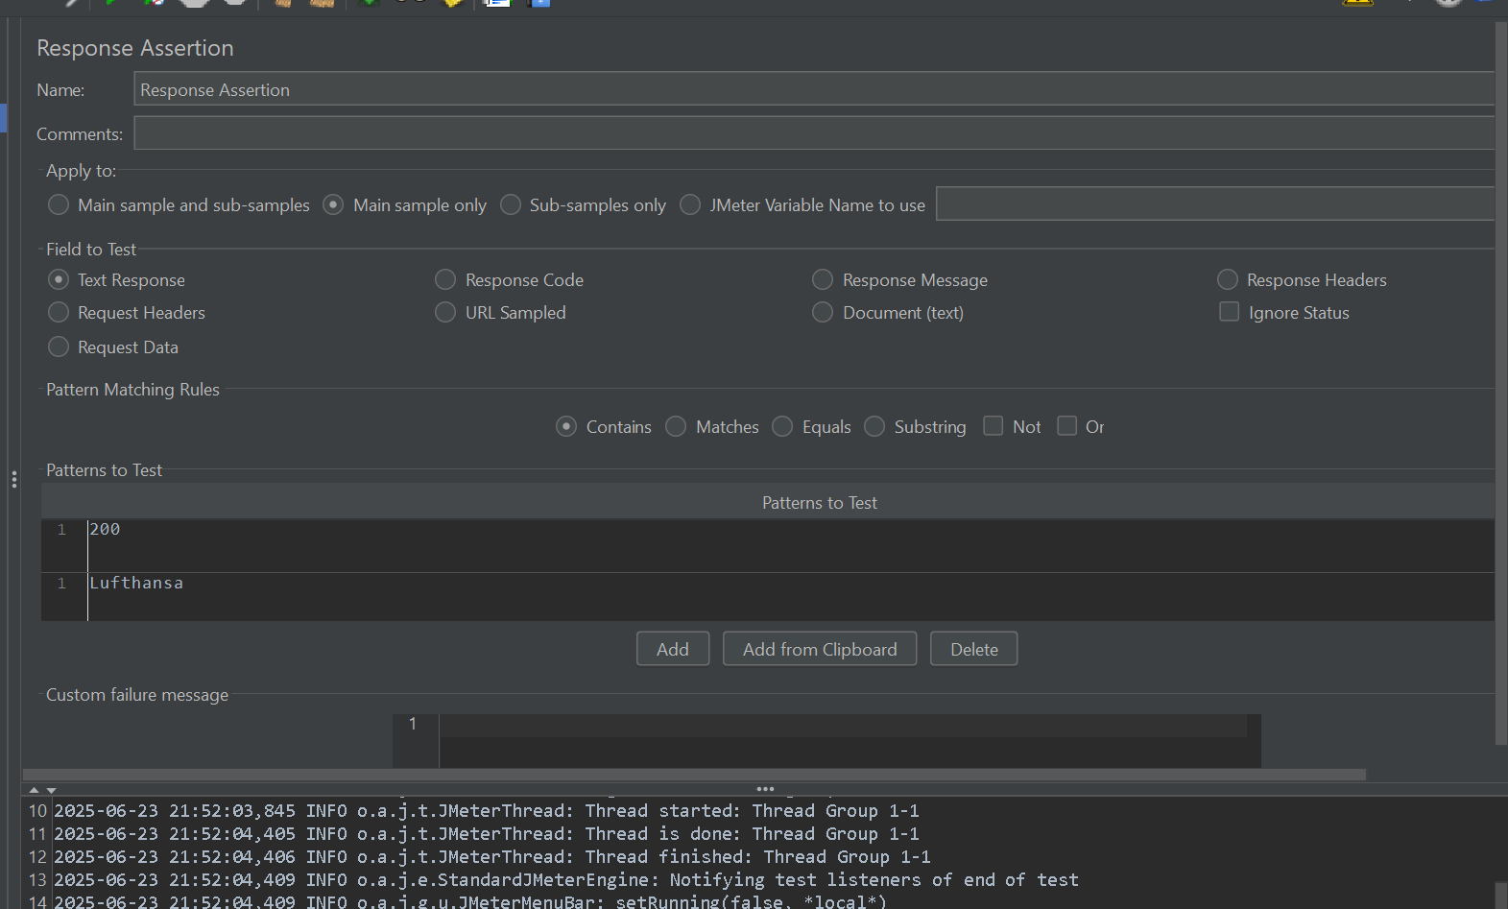

* **Use Cases:**
  + Validate response text (e.g., "Login successful")
  + Check HTTP status code (e.g., 200 OK)
  + Match header values
  + Pattern match dynamic text
* **Example:**  
  Match response body contains: "Welcome"
* **Benefit:** Fundamental for any functional or performance validation

**📦 Size Assertion**

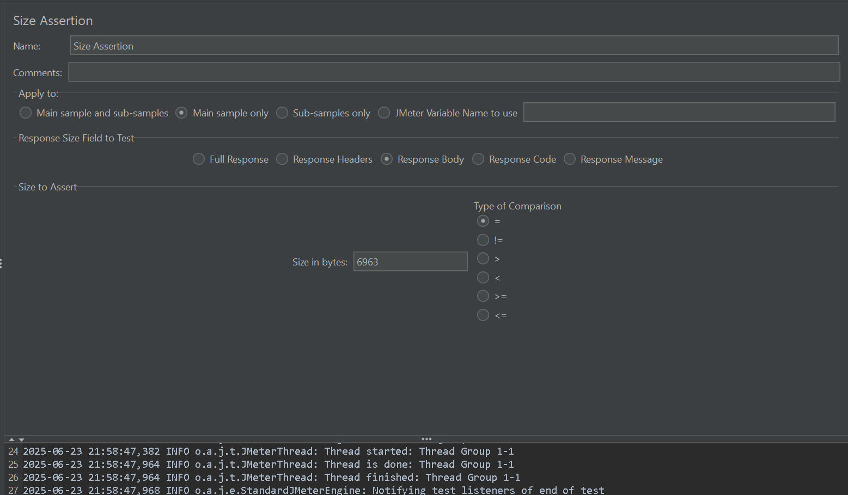

* **Use Cases:**
  + Validate size of image/file or response
  + Check for unexpected data bloat
  + Ensure empty responses are truly empty
* **Example:**  
  Response size **must be ≤ 10,000 bytes**
* **Benefit:** Detects payload size issues

**⏱️ Duration Assertion**

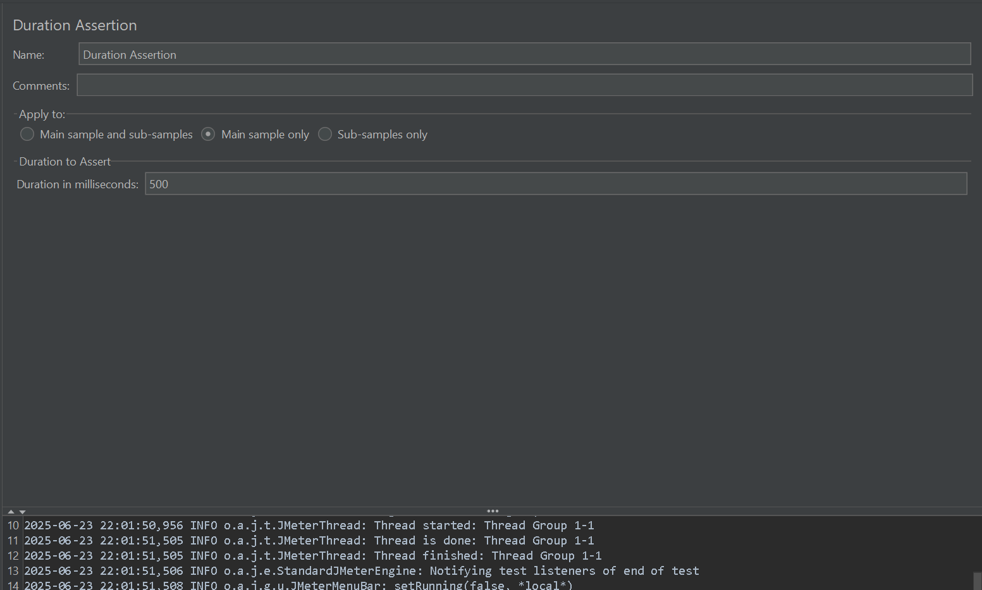

* **Use Cases:**
  + SLA enforcement (e.g., "Search must respond < 1s")
  + Identify slow endpoints
* **Example:**  
  Max response time allowed: **2000 ms**
* **Benefit:** Performance-focused; flags latency issues early

**🧾 Format-Specific Assertions**

**🧩 JSON Assertion**

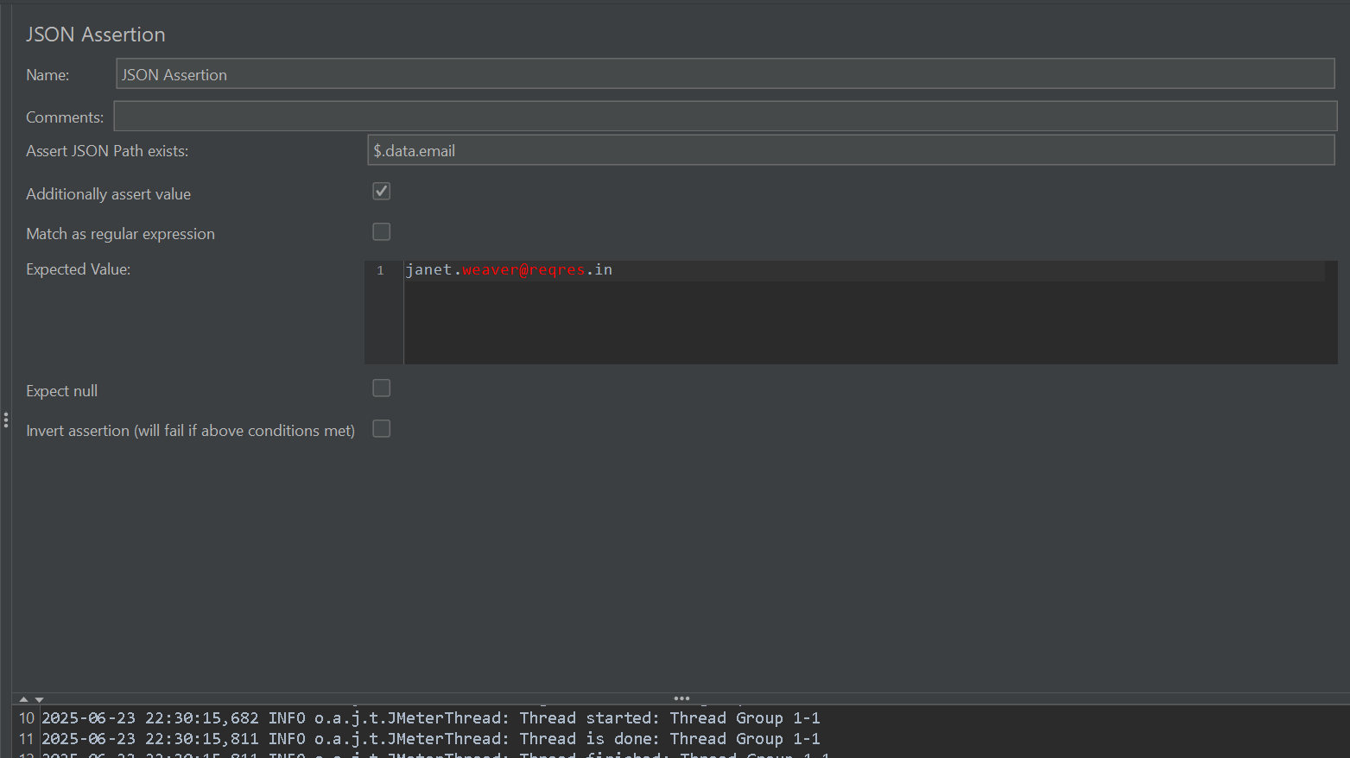

* **Use Cases:**
  + Validate key/value in JSON response
  + Check nested object values
* **Example:**  
  JSON Path: $.status → Expected: "success"
* **Benefit:** Ideal for REST API validation

**📚 JSON JMESPath Assertion**

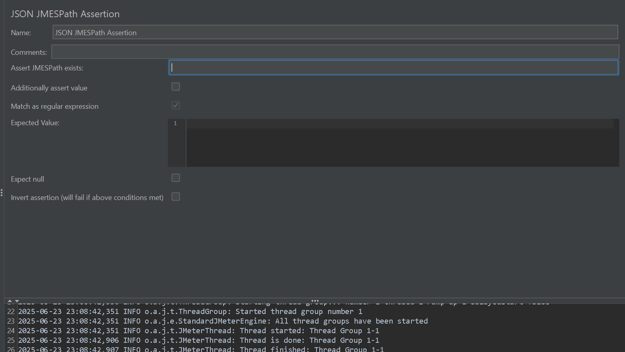

* **Use Cases:**
  + Navigate complex/nested JSON
  + Conditional checks (e.g., if type == "A" then value != null)
* **Example:**  
  users[?id==123].status | [0] → Expected: "active"
* **Benefit:** Flexible and powerful for deep JSON validation

**📘 XML Assertion**

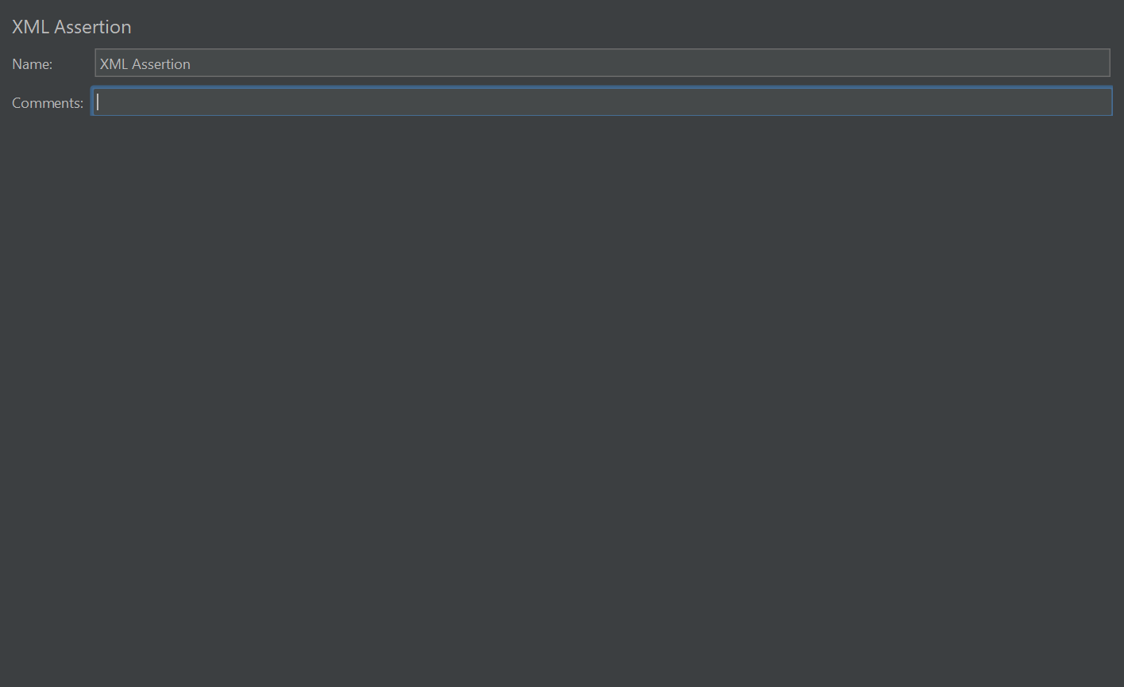

* **Use Cases:**
  + Confirm valid XML structure
  + Assert tag values
* **Example:**  
  XML contains: <status>OK</status>
* **Benefit:** Critical for SOAP or XML-based APIs

**🧬 XPath Assertion**

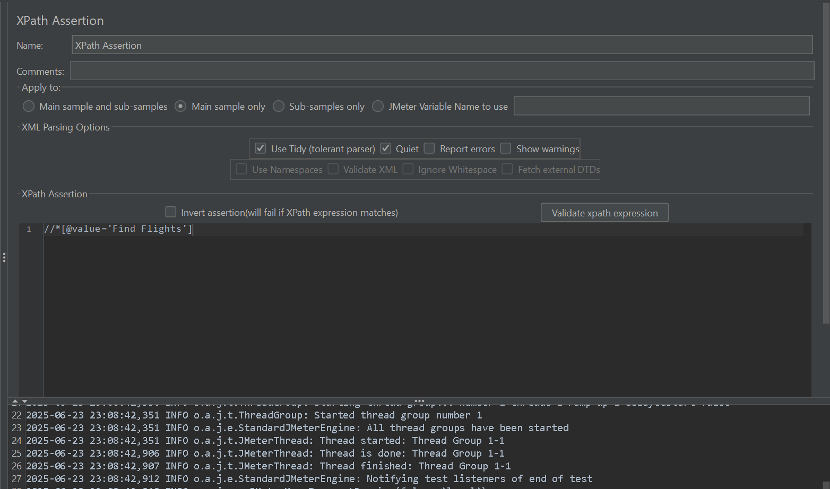

* **Use Cases:**
  + Locate and validate specific XML nodes/attributes
  + Node count checks
* **Example:**  
  XPath: /users/user[@id='10']
* **Benefit:** Fine-grained control over XML validation

**🧬 XPath2 Assertion**

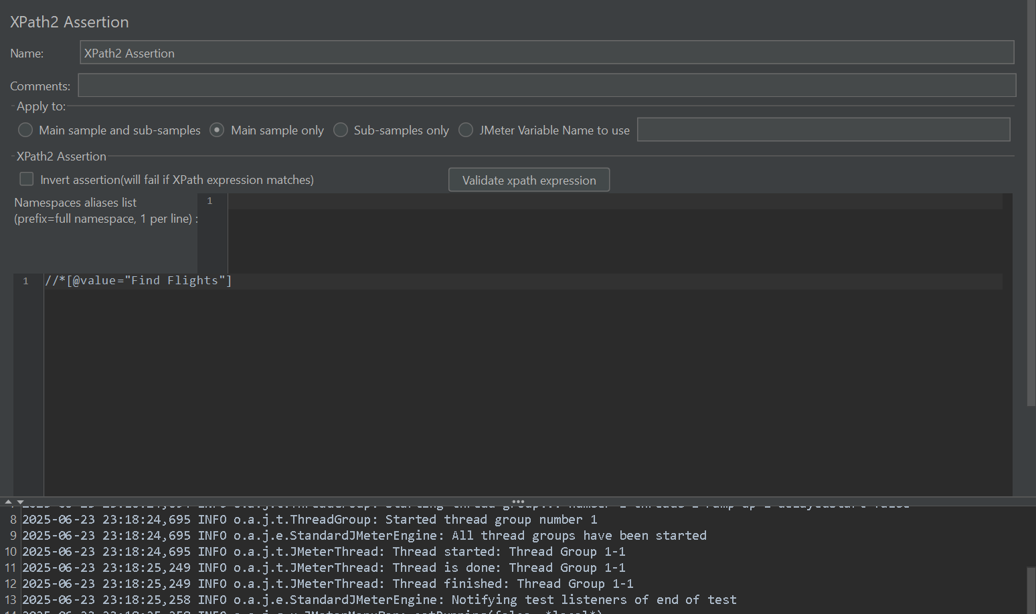

* **Use Cases:**
  + Advanced XML logic (e.g., date/time, math)
* **Example:**  
  //item[price > 100]
* **Benefit:** Improved XPath engine (XPath 2.0) for robust queries

**📄 XML Schema Assertion**

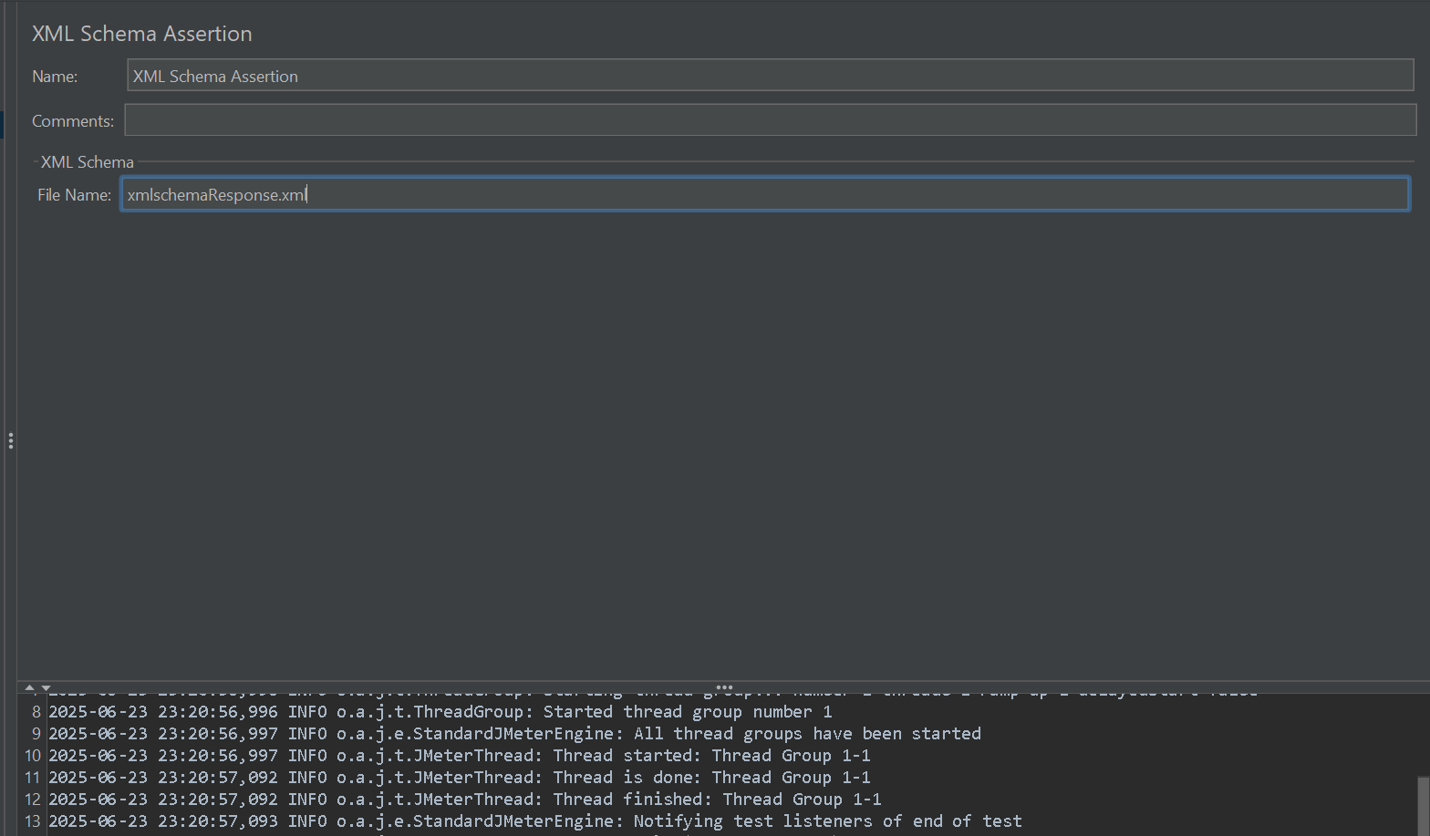

* **Use Cases:**
  + Validate against .xsd schema
  + Enforce contracts for XML services
* **Example:**  
  XML must match schema: response_schema.xsd
* **Benefit:** Ensures structural/data-level XML integrity

**🔒 Security & Encryption Assertions**

**🔐 MD5Hex Assertion**

* **Use Cases:**
  + Confirm content integrity (e.g., downloaded files)
* **Example:**  
  Response MD5 = 5d41402abc4b2a76b9719d911017c592
* **Benefit:** Simple but powerful integrity check

**🔏 SMIME Assertion**

* **Use Cases:**
  + Validate secure email messages
  + Check encryption or signature
* **Benefit:** Specialized validation for S/MIME mail flows

**🖥️ Citrix Assertions *(Citrix Plugin Required)***

**🖥️ Citrix Assertion**

* **Use Cases:**
  + Validate visual elements in Citrix apps
* **Example:**  
  Confirm "Dashboard" window opens
* **Benefit:** Key for Citrix app flow correctness

**🖥️ Citrix Session State Assertion**

* **Use Cases:**
  + Assert on control/window states
  + Validate UI readiness
* **Example:**  
  Assert window title = "Home - Admin"
* **Benefit:** Granular control for Citrix environments

**🔍 Advanced Scripting Assertions**

**🧠 JSR223 Assertion *(Recommended over BeanShell)***

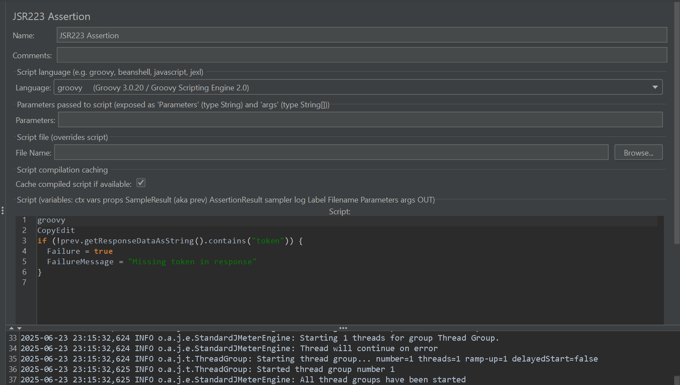

* **Use Cases:**
  + Write complex validation in **Groovy**
  + Use external data, conditionals, DB checks
* **Example:**

groovy

CopyEdit

if (!prev.getResponseDataAsString().contains("token")) {

Failure = true

FailureMessage = "Missing token in response"

}

* **Benefit:** High-performance and fully customizable

**🐚 BeanShell Assertion**

* **Use Cases:**
  + Legacy/custom scripts
  + Debug with response printing
* **Example:**

java

CopyEdit

if (prev.getTime() > 5000) {

Failure = true;

FailureMessage = "Too slow!";

}

* **Benefit:** Versatile, but slower than JSR223/Groovy

**⚖️ Miscellaneous Assertions**

**🆚 Compare Assertion**

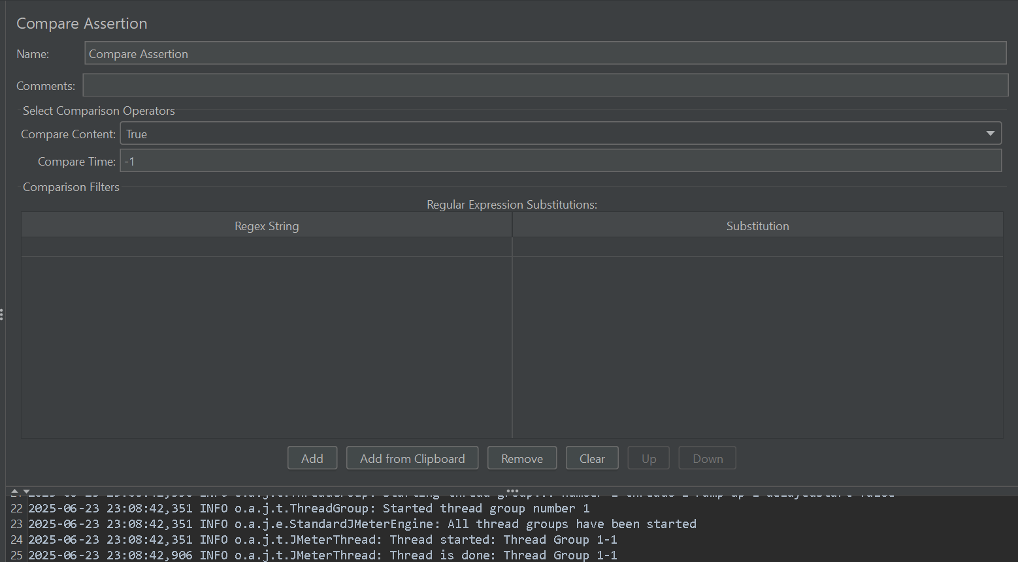

* **Use Cases:**
  + Regression testing (compare to baseline)
  + A/B testing validation
* **Example:**  
  Compare response to expected_response.txt
* **Benefit:** Ensures consistency over versions/flows

**🌐 HTML Assertion**

* **Use Cases:**
  + Validate well-formed HTML output
  + Catch broken markup or missing tags
* **Example:**  
  Fail if HTML has unclosed <div>
* **Benefit:** Validates frontend renderability—avoid browser issues

**🔚 Summary Table (Cheat Sheet)**

| **Assertion Type** | **Icon** | **Best For** | **Language/Tool Used** |
| --- | --- | --- | --- |
| Response Assertion | 🔁 | Text, headers, status code | GUI |
| JSON Assertion | 🧩 | Simple JSON validation | JSON Path |
| JSON JMESPath Assertion | 📚 | Advanced JSON structure checks | JMESPath |
| Size Assertion | 📦 | Payload size checks | GUI |
| Duration Assertion | ⏱️ | SLA / speed validation | GUI |
| XML Assertion | 📘 | Basic XML validity | GUI |
| XPath / XPath2 Assertion | 🧬 | Complex XML content validation | XPath / XPath 2.0 |
| XML Schema Assertion | 📄 | Contract validation against .xsd | GUI |
| MD5Hex Assertion | 🔐 | Data integrity | GUI / Hash |
| SMIME Assertion | 🔏 | S/MIME signature check | GUI |
| Citrix Assertions | 🖥️ | Citrix app UI verification | Citrix Plugin |
| JSR223 Assertion | 🧠 | Complex scripting (Groovy) | Groovy |
| BeanShell Assertion | 🐚 | Custom logic (Java-like) | BeanShell |
| Compare Assertion | 🆚 | Golden file vs. current response | GUI / File Compare |
| HTML Assertion | 🌐 | HTML structure validation | W3C-like validation |